Scala programming

Name – chaithanya gowda l

Write a Scala program that creates an abstract class Shape with an abstract method area. Implement subclasses Rectangle and Circle that override the area method.

INPUT:

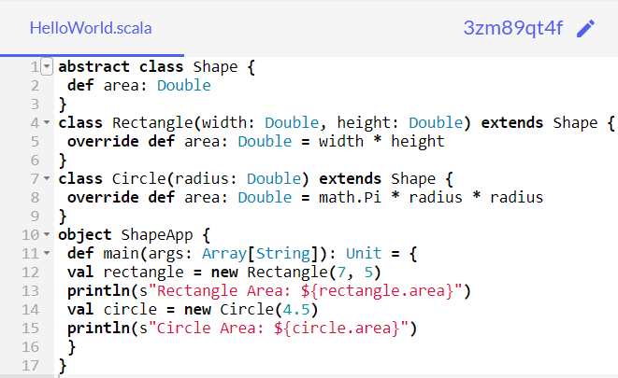

**OUTPUT:**

